# %DES_STAT

## Syntax

%DES_STAT(_DATSRC =, _OUT = DES_STAT, _AP =, _GROUP =, _VAR =, _OVERALL_NEED = Y, _OVERALL_EXCLUDE= , STAT = %str(N MEAN STD MEDIAN MIN MAX Q1 Q3), _DEC_SPE = , _ROUND = N, _OV = Y);

# Required Arguments

**_datsrc**

Specifies the source dataset, such as the original ADaM dataset e.g. ADLB, ADVS, or any dataset with PARAMCD, AVAL exist.

**_out**

default: DES_STAT  
Specifies the name of the output dataset.

**_AP**

Specifies a space-separated list of analysis parameters existing in **_datsrc**, which should be common across all subjects, such as the list of timepoint, test e.g. AVISITN AVISIT ATPTN ATPT PARAMN PARAMCD PARAM. It is recommended to list numeric variables first among the identical variables to facilitate automatic sorting, e.g. list AVISITN before AVISIT.

**_GROUP**

To indicate which variable in **_datsrc** contains grouping information of each subject such as TRTxxP/A, TRTP/A, WGHTG1, etc. Avoid using numeric variables such as TRTxxP/AN, TRTP/AN, WGHTG1N.

**_VAR**

Specifies a space-separated list of variables from **_datsrc** to be analyzed such as AVAL, CHG, etc.

**_OVERALL_NEED**

default: Y  
To indicate whether an “Overall” summary group is required, takes value as Y or N.

**_STAT**

default: N MEAN STD MEDIAN MIN MAX Q1 Q3  
Specifies the list of statistics required.

# Optional Arguments

**_OVERALL_EXCLUDE**

Specifies a “|” separated list of values of **_GROUP**. Records whose **_GROUP** values included in the list will be excluded from the summary “Overall”group, e.g. _OVERALL_EXCLUDE = PLB|DOSE 1. An “Overall” group is created by summarizing all existing groups’ information if **_OVERALL_EXCLUDE** is not specified.

**_DEC_SPE**

Specifies a “|” separated list as (PARAMCD1 decimal1| PARAMCD2 decimal2|……) to modify decimal place of certain PARAMCD(s) manually, e.g. BMI 1|ZWEIGHT 1.

**_ROUND**

default: N  
Specifies whether to round the statistics first before put into characteristic form, takes value as Y or N, If N, it will maintain the direction of a rounded 0 such as -0.00.

**_OV**

default: Y  
Specifies whether to keep the original value of (MIN, MAX) or not, takes value as Y or N.

# Details

The **%DES_STAT** macro is designed to enable users to generate descriptive statistics with minimal modification to **_datsrc** such as ADaM datasets like ADVS, ADLB, etc. The macro generates descriptive statistics and modify the decimal automatically based on value of AVAL of each PARAMCD. It produces two datasets as output, one of which is a combined descriptive statistics table ready to output, and the other one with _RAW suffix contains descriptive statistics with raw values computed from **_datsrc** in case a further check is required (by default, **DES_STAT** and **DES_STAT_RAW**).

**_AP** specifies the list of variables which are common across all subjects, such as timepoint, parameter/test. _**GROUP** specifies the variable of grouping information, which differs per subject, thus variables of **_AP** and **_GROUP** should be mutually exclusive. In addition, **_AP** and **_GROUP** should both be a subset of variables in **_datsrc**.

Sometimes, an “Overall” summary group is required for summarizing all or most groups’ (usually groups with varying dose of active study drug) information. It is common to exclude the placebo group in such scenarios. **%DES_STAT** allows user to exclude specific group(s) by using the optional argument **_OVERALL_EXCLUDE** by specifying a “|” separated list of values of **_GOURP** to be excluded from the “Overall” summary group. (see Example 2).

It is often the case that a specific PARAMCD is derived based on other PARAMCDs, such as BMI, results in outcome of irrational number. **%DES_STAT** allows user to modify specific decimal for certain PARAMCD manually by using optional argument **_DEC_SPE** (See Example 3).

User may notice that introduction above implies that **%DES_STAT** macro is mainly designed for “Change from Baseline” table, but, by little modification, it can also apply on other tables such as demographics, baseline characteristics, etc. (See Example 4).

# Examples

## Example 1: Generate a change from baseline table.

%DES_STAT(_DATSRC = VSCHG01,   
 _OUT = CFB,   
 _AP = PARAMN PARAMCD PARAM AVISITN AVISIT ATPTN ATPT,   
 _GROUP = WGHTG2,   
 _VAR = AVAL CHG,   
 _OVERALL_NEED = Y,   
 _STAT = N MEAN STD MEDIAN MIN MAX,   
 _ROUND = Y,   
 _OV = Y);

## Example 2: _OVERALL_EXCLUDE demonstration

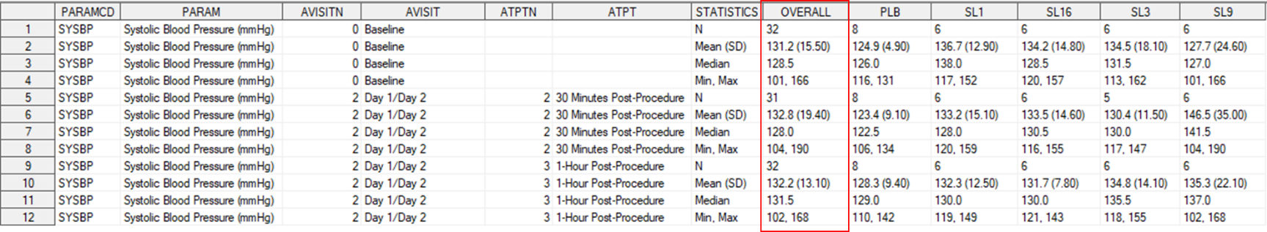%DES_STAT(_DATSRC = VSCHG01,   
 _OUT = VSCHG02,   
 _AP = PARAMN PARAMCD PARAM AVISITN AVISIT ATPTN ATPT,   
 _GROUP = TRTA,   
 _VAR = AVAL CHG,  
 _OVERALL_NEED = Y,   
 _STAT = N MEAN STD MEDIAN MIN MAX,   
 _ROUND = Y,   
 _OV = Y);

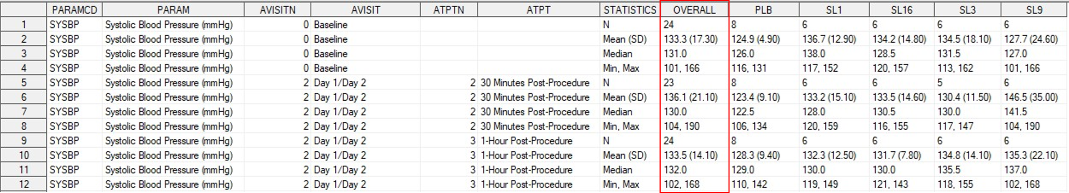%DES_STAT(_DATSRC = VSCHG01,   
 _OUT = VSCHG02,   
 _AP = PARAMN PARAMCD PARAM AVISITN AVISIT ATPTN ATPT,   
 _GROUP = TRTA,   
 _VAR = AVAL CHG,  
 _OVERALL_NEED = Y,   
 _OVERALL_EXCLUDE = PLB,   
 _STAT = N MEAN STD MEDIAN MIN MAX,   
 _ROUND = Y,   
 _OV = Y);

%DES_STAT(_DATSRC = VSCHG01,   
 _OUT = VSCHG02,   
 _AP = PARAMN PARAMCD PARAM AVISITN AVISIT ATPTN ATPT,   
 _GROUP = TRTA,   
 _VAR = AVAL CHG,  
 _OVERALL_NEED = Y,   
 _OVERALL_EXCLUDE = PLB|SL1,   
 _STAT = N MEAN STD MEDIAN MIN MAX,   
 _ROUND = Y,   
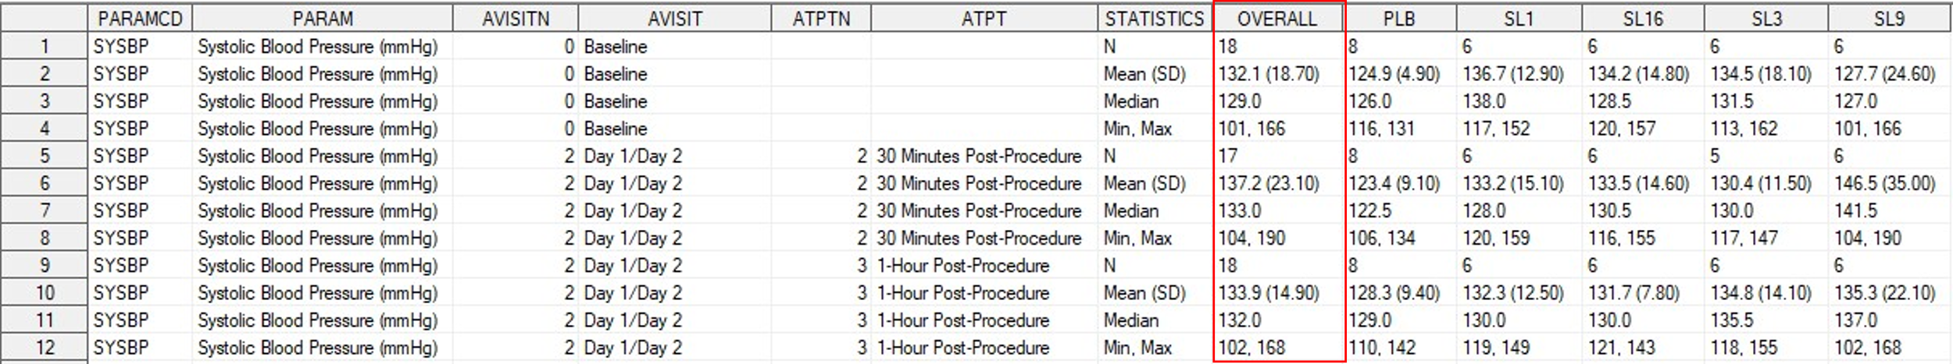 _OV = Y);

## Example 3: modify decimal of AVAL of derived PARAMCD manually

%DES_STAT(_DATSRC = VSCHG03,   
 _AP = PARAMN PARAMCD PARAM APHASEN APHASE AVISITN AVISIT,   
 _GROUP = TRT,   
 _VAR = AVAL CHG,   
 _OVERALL_NEED = N,   
 _STAT = N MEAN STD MEDIAN MIN MAX,   
 _ROUND = Y,   
 _OV = N);  
%DES_STAT(_DATSRC = VSCHG03,   
 _AP = PARAMN PARAMCD PARAM APHASEN APHASE AVISITN AVISIT,   
 _GROUP = TRT,   
 _VAR = AVAL CHG,   
 _OVERALL_NEED = N,   
 _STAT = N MEAN STD MEDIAN MIN MAX,   
 _ROUND = Y,   
 _DEC_SPE = BMI 1,   
 _OV = N);  
  
  
  
  
  
  
## Example 4: Apply on demographic table

To apply on dataset without PARAMCD, create dummy PARAMCD and AVAL manually.

data ADSL01;   
 set ADS01.ADSL;   
 PARAMCD = "AGE";   
 AVAL = input(AGE, best.);   
run;  
%DES_STAT(_DATSRC = ADSL01,   
 _AP = PARAMCD,   
 _GROUP = WGHTG2,   
 _VAR = AVAL,   
 _OVERALL_NEED = Y,   
 _STAT = N MEAN STD MEDIAN MIN MAX,   
 _ROUND = Y,   
 _OV = Y);  
